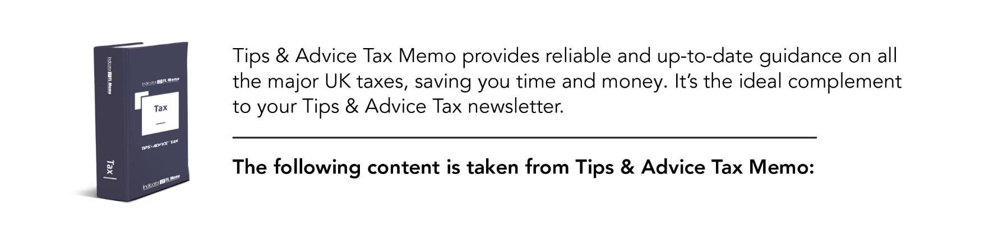

For more information about Tax Memo please click here

VAT invoices

A business must prepare VAT invoices for all taxable sales. Credit notes adjust sales that have already been invoiced - these also have specific rules. A VAT invoice must be provided whenever a registered trader supplies taxable goods or services to another registered trader. There is an exception where only zero-rated or exempt supplies are being made in the UK. There is no requirement to provide VAT invoices to non-registered customers, although it is prudent to do so unless the supplier is certain that the purchaser is not registered. Special rules apply to invoices issued by Northern Ireland (NI) traders to customers in EU member states.
VAT invoices must not be issued in respect of:
- supplies to customers operating a self-billing scheme;
- gifts of goods under a promotion scheme;
- supplies under a second-hand goods scheme; or
- supplies under the tour operators' margin scheme (see VAT Memo for details).
For the treatment of errors see.

Time limits
Notice 700 para 16.2.3
Where a VAT invoice is required, the general rule is that it must be issued within 30 days of the tax point.
This time limit can be extended if HMRC agrees.
Also, it is possible to extend the time if the trader is waiting for an invoice from its supplier or subcontractor, or a newly registered trader has not yet received notification of its VAT registration number. Once this has been received, invoices should be issued within the following 30 days.
Standard invoice
Information required

SI 1995/2518 reg 14
Traders can usually recover input tax if a valid VAT invoice is held, which contains all of the following information:
- name, address and VAT registration number of the supplier;
- purchaser's name and address;
- unique identifying number, which must be sequential;
- date of issue;
- tax point date;
- identifying description of the supply, detailing the quantity of goods or extent of services, the rate of VAT and the VAT-exclusive price;
- unit price;
- total amount payable excluding VAT;
- rate of any cash discount available;
- applicable rates of VAT; and
- total amount of VAT charged.

Memo points
1. The unit price for services may be an hourly rate or a standard price for that particular service. The unit price does not need to be shown where it is not normally provided in a particular business sector and the customer does not require it.
2. Any zero-rated or exempt items included on the invoice must be clearly identified and totalled separately.
3. Invoices must generally be in sterling. If an invoice is supplied in a foreign currency, the sterling equivalent must be shown for the total and the VAT payable, using an approved exchange rate. Invoices in euros need not show the VAT-exclusive price for each description but all other figures must be given in sterling.
4. Invoices need not be in the English language, although a translation must be made available to a visiting HMRC officer within 30 days of a specific request.

SI 1995/2518 reg 16A

If the invoice total is £250 or less, and there are no exempt supplies, a less detailed VAT invoice may be issued, which need only show:
- the name, address and VAT number of the supplier;
- the time of supply;
- an identifying description of the supply;
- the total VAT-inclusive amount; and
- for each rate of VAT charged, the gross amount payable including VAT and the VAT rate.
All items must be shown in sterling (so foreign currency must be converted).
If the supply is paid for by credit card, the credit card voucher may be adapted to act as a less detailed VAT invoice, in which case it is important to remember that only one VAT invoice can be issued for each supply.

VAT numbers
All registered persons are allocated a unique VAT registration number. A UK VAT number consists of nine digits. For NI businesses trading within the EU, the prefix XI is also used. Each of the member states has an allocated prefix, but the format of the VAT number may be different.

Checking the validity of a VAT number
HMRC provides an online VAT number checker, which can be found at tiny.cc/tm81125a.
The validity of an EU VAT number can be checked at tiny.cc/tm81125b. This check will not tell the customer whether the VAT number is being used by the correct supplier, though.

Rounding of VAT amount
Notice 700 para 17.5
As a concession, the total VAT payable on an invoice may be rounded down to the nearest whole penny, provided that the VAT paid by the customer is the same as the VAT paid to HMRC.
Where an invoice includes more than one supply, the VAT on each line must either be rounded:
- down to the nearest 0.1p; or
- up or down to the nearest 1p or 0.5p.
A consistent approach must be adopted. Again, at the end of the invoice, the total amount of VAT may be rounded down to the nearest whole penny.
Example
Mr A issues an invoice showing two lines of goods. The actual values are: 97.76p and 196.64p.
He can either round:
- down to the nearest 0.1p, which gives amounts of 97.7p and 196.6p; or
- to the nearest 1p for 97.76p to give 98p, and to the nearest 0.5p for 196.64p to give 196.5p.

